Advanced search page default query link rules

1.All spaces, / are changed to-

2.Remove some +, "", and # special symbols

3.Words should be case sensitive

For example, search the 2.5 "SAS / SATA Hot Swap in drive bay

The link is: <https://digicor.com.au/advanced-search?Drive-Bays=2.5-SAS-SATA-Hot-Swap>

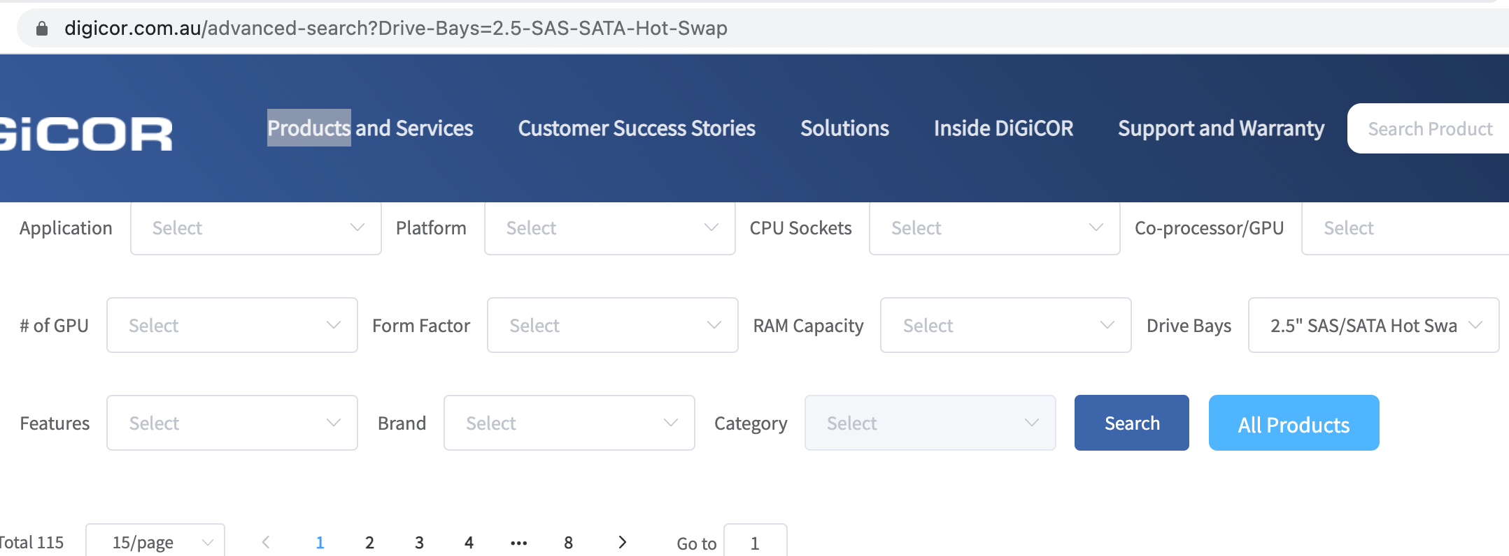

search the 2 in # of GPU

The link is: <https://digicor.com.au/advanced-search?of-GPU=2>

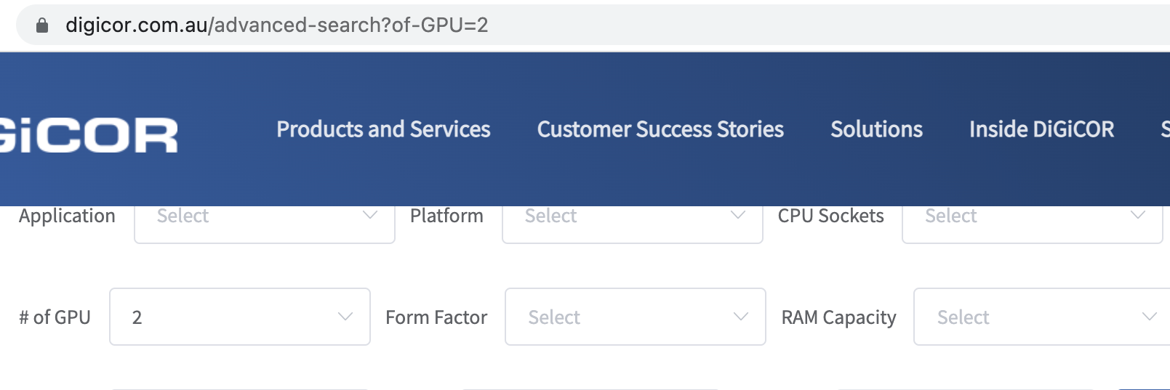

search the Dual 10G SFP+ in Features and INTEL in Brand

The link is: <https://digicor.com.au/advanced-search?Features=Dual-10G-SFP&Brand=INTEL>

